OUT OF YOUR HANDS 2016 KS2 RESOURCES LESSON 1: YOUR DIGITAL FOOTPRINT
Lesson plan
Activity 2: Create a safe profile

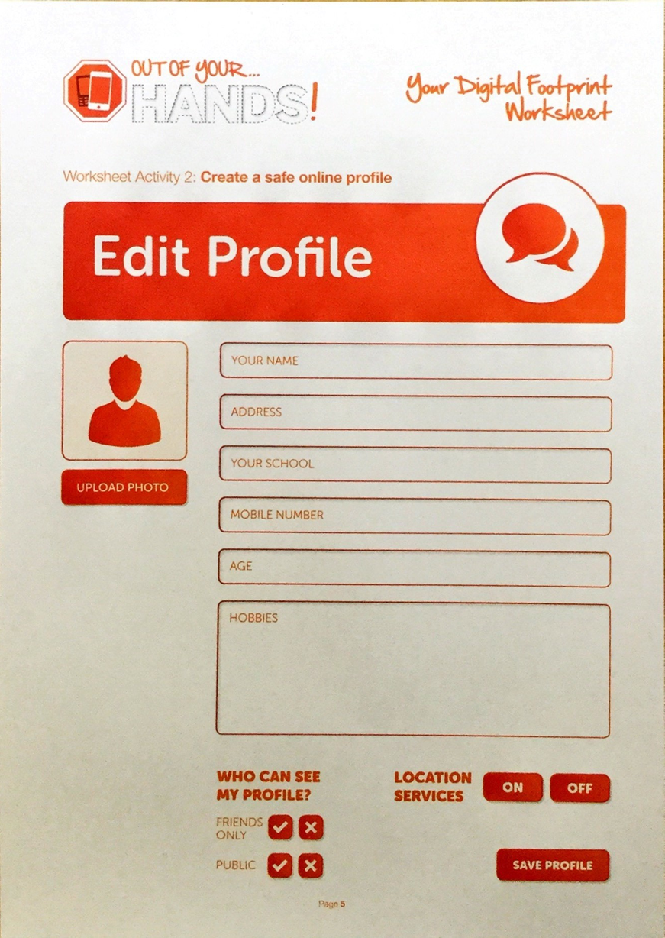
Worksheet Activity 2: Create a safe profile and fill it in, discussing it with an adult.
Answers:

Ideally, the answers below are the ones that you child should give you. If not discuss their answers and explain the reasons as to why their answers may be of concern

Pupil Activities
Profile picture | pupils should choose a nickname, not real name
Your name | pupils should not fill this in
Your school | pupils should not fill this in
Your address | pupils should include only a city at the very most, or just UK
Mobile number | pupils should not include one
Hobbies | OK, but do not give away locations
Age | OK, as this should stop most (decent) adults from contacting them, although many pupils pretend to be older than they are to get a social media account before 13
Only friends can see my profile | Selected
Location services | Switched off

